

**Pinky and Peet – The little Aussie Bush Lizards**

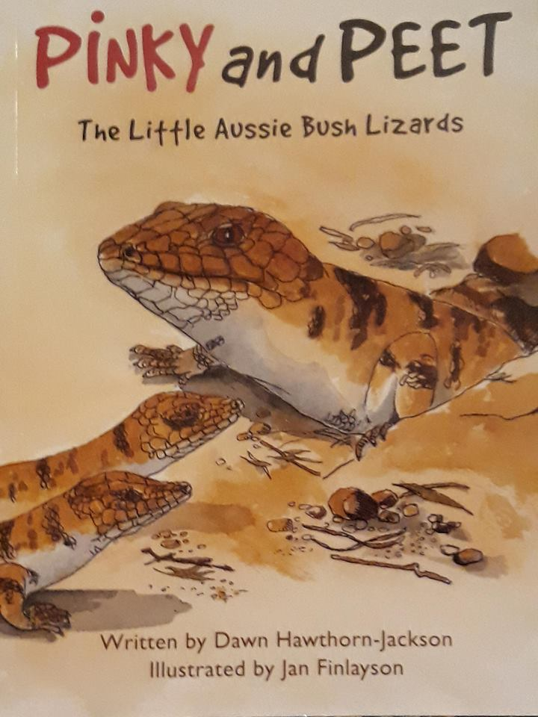

**A presentation relevant to JP, Primary, IELP and NAP teachers as well as teachers of adult migrants.**

**Date:** Thursday 21st June 2018

**Time:** 5:00 - 7:30pm

**Venue:** Our Lady of the Sacred Heart College

(OLSH), Regency Road, Enfield

E*nter via back car park on Corralyn Avenue.*

**$15 Members, $25 Non-members**

Membership forms will be available on the night if non-members wish to join. $60 per annum.

In this Presentation Jan Finlayson, a former EALD teacher and the Illustrator of this book, will talk about how she became an illustrator and will share with you the teaching resources developed for this book.

The session addresses the following Teacher Standards:

2.1 Content and teaching strategies of the teaching area

2.2 Content selection and organisation

2.5 Literacy Strategies

3.2 Plan, structure and sequence learning programs

3.4 Select and use resources

6.2 Engage in professional learning and improve practice

6.3 Engage with colleagues and improve practice

7.4 Engage with professional teaching networks and broader communities

Light refreshments will be provided.

**Register on Trybooking by Tuesday 19th June 2018:**

[**https://www.trybooking.com/390759**](https://www.trybooking.com/390759)